TOP FIVE OBJECTIONS TO VOTING
Objection - “I am not going to vote. All the candidates are bad.”
Answer - “As a citizen of America, you have been given a privilege to be involved in the elective franchise. Many have died for your right to enjoy this freedom in a free country. Not to vote is an abdication of your voice and your responsibility.”
Objection - “The lesser of two evils is still evil.”
Answer - “Should we not always desire less evil as opposed to more.”
Objection - “I am concerned about the immigration policy.”
Answer - “We must maintain the rule of law or we descend into anarchy.”
Objection - “I don’t like Democratic or Republican party so I will vote Libertarian.”
Answer - “As Christians, know their stance on abortion and several other key moral issues? Check out their beliefs before you vote. Remember you are accountable to God first and upholding His moral standards.”
Objection - “I think the parties should just fail and we can start over.”
Answer - “Remember the next President will appoint 3-4 justices and hundreds of lower court judges. This will mean we stand to lose our freedom of religion and speech as well as other freedoms granted by our Constitution."

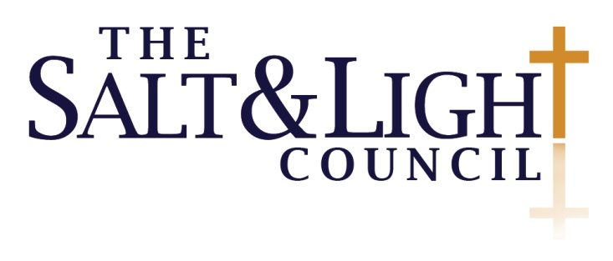

Website: www.SaltandLightCouncil.org
Email us: office@SaltandLightCounci.org
Call us: 888 SALT 654

